Pakistan J. Zool., vol. 43(3), pp. 447-459, 2011.

Ovarian Maturation Stages and Size at Sexual Maturity of Penaeus indicus (H. Milne Edwards, 1937) in the Lagoon Water of Sonmiani Bay, Balochistan

Zunaira Amanat¹ and Naureen Aziz Qureshi²*

¹Centre of Excellence in Marine Biology, University of Karachi, Karachi 75270, Pakistan

²Department of Fisheries and Aquaculture, University of Veterinary and Animal Sciences, Syed Abdul Qadir Jilani Road, Lahore 54000

Abstract.- The reproductive biology of Penaeus indicus H. Milne Edwards, 1837 was studied from the coastal water of Pakistan during the period July 2006 to June 2007 to assist with establishment of minimum permissible capture size for this fishery. This is a first attempt to study ovarian maturation stages and size at sexual maturity of this species that was abundantly collected from Sonmiani Bay. The shrimps were collected from the Damb Bunder, Sonmiani Bay Lagoon locally known as Miani Hor (25° 27' N/ 66° 33' E), which is 95 km from Karachi. The present study focused on the vital aspects of reproductive biology: maturation stages of ovaries, spawning season and size at sexual maturity. During maturation ovaries in P. indicus exhibited distinctive colour changes like other penaeid shrimps that can be related to five reproductive stages: undeveloped, developing, nearly ripe, ripe and spent. The histological study confirmed that these stages were comparable with ovarian maturation stages based on colour. The percentage ripe and spent stages were combined as ready to spawn, spawning or just spawned showed that for P. indicus the peak spawning activity was during August to October and a secondary peak was observed during February to March. When ovaries pass through developmental stages the body size and weight also increases. Statistically significant in ovarian developmental stages (colouration) and morphological character such as total length (TL), carapace length (CL), rostral length (RL), telson length (Ts.L) were observed. The size at which L₅₀ of the population was a morphologically mature estimated size at onset of sexual maturity was 13.33 cm. This paper provides an easy to use technique for estimating maturity that could be useful for management of shrimp fisheries.

Keywords: Histological, Pakistan, Penaeus indicus, reproductive biology, Sonmiani bay, size at maturity, spawning season.

INTRODUCTION

The reproductive process of penaeid shrimps involves attaining maturity, mating and spawning. Penaeid shrimps have complex seasonal patterns of reproduction, greatly impacted by variable environmental conditions and vary both within and between species (Crocos, 1987a, b; Dall et al., 1990; Crocos and van der Velde, 1995). It is well known penaeid shrimp are iteroparous and they frequently spawn, with a short interval between successive spawning events; in a single year they may have several broods (Rao, 1968).
Knowledge of spawning seasons and distribution of spawning areas are important for
the management of fisheries and for cultivation of commercially important species. Spawning for
____________________________
* Corresponding author: noureenqureshi@uvas.edu.pk
0030-9923/2011/0001-0447 $ 8.00/0
Copyright 2011 Zoological Society of Pakistan.
penaeid shrimp in the wild usually occurs offshore in much shallower open water of less than 50 m depth (Dall et al., 1990). The temperate waters penaeid shrimps have shorter maturation and spawning season than tropical waters penaeid shrimps because of lower water temperatures during winter (Hideo, 2001). The spawning seasons of penaeid shrimps are most commonly determined by the percentage of mature females present in the catch or from the changes in gonadal indices (Crocos and Kerr, 1983; Garcia, 1985; Bauer and Vega, 1992; Crocos and Coman, 1997; Minagawa et al., 2000; Crocos et al., 2001; Costa and Fransozo, 2004; Aragon-Noriega and Garcia-Juarez, 2007).
In female penaeid shrimps, gonadal maturation can be evaluated from a number of parameters. Visual assessment on the basis of ovary size and color is the most common method (Rao, 1968; Primavera, 1980; Brown and Patlan, 1974; Abdel Razek, 1985; Castille and Lawrence, 1989; Hossain et al., 1991; Ayub and Ahmed, 1992; Abdel Razek et al., 1994; Jayawardane et al., 2003). In addition histological changes can also be used as indicators of ovarian maturation and visual changes have been correlated to histological changes in the ovary (King, 1948; Crocos and Kerr, 1983; Quinito and Millamena, 1992; Medina et al., 1996; Quintero and Gracia, 1998; Ayub and Ahmed, 2002; Peixoto et al., 2003).
Zupanovic (1971) determined the gonadal maturity of Pakistani penaeid shrimps and used this information to describe their spawning seasons. Various authors also discussed the spawning seasons (Ahmed, 1980; Van Zalinge et al., 1987) and maturation (Sultana, 1985) of penaeid shrimps from Pakistani coastal waters. Hassan (1983) also studied the extent of spawning seasons of penaeid shrimps on the basis of the abundance of their eggs and larvae. Ayub and Ahmed (1992) described the maturation and spawning of Pakistani penaeid shrimps (P. penicillatus, P. merguiensis, M. affinis and Pp. stylifera) by coloration along with the histology of ovaries of same species (Ayub and Ahmed, 2002).
Penaeus indicus (H. Milne Edwards, 1837) is one of the valuable penaeid shrimp species of genus Penaeus found in the coastal waters of Pakistan (Tirmizi and Bashir, 1973) as well as to the south in East Africa, Madagascar, India, Sri Lanka, South China, the Philippines and Northern Australia (Jayawardane et al., 2002). Their populations are present at the depth of about 90 m shelf areas from the coastline but are most abundant on sand or mud in less than 30 m depth in shallow waters (Fischer and Bianchi, 1984).
Despite the great economic value of shrimps in Pakistan, the information on the biology of Pakistani penaeid shrimps is sparse and scanty especially biology of species from coastal areas of Balochistan. The present study is designed to determine the spawning seasons, size at first maturity and maturation stages of female P. indicus occurring in Sonmiani Bay lagoon that is one of the commercially important lagoon of Pakistan.

MATERIALS AND METHODS

Study site
Pakistan has geographically and ecologically diverse coastline composed of harbours, estuaries, bays and creeks with diversity in animal forms exhibiting a wide range of characteristics. The length of Pakistan coast is about 1,050 km, consists of 350 km that falls within the province of Sindh and approximately 700 km that lies in the province of Balochistan, and the Exclusive Economic Zone (EEZ extends to a distance of 200 nautical miles out from its coastal baseline) about 240,000 square km (Saifullah et al., 2004).
The Sonmiani Bay or Miani Hor (25° 27' N/ 66° 33' E) is 95 km from Karachi (Fig. 1), the lagoon covers an area of 7,471 ha. It is a 60 km long and 7 km wide tortuous body of water, which is connected to the north Arabian sea by a 4 km wide mouth. The average width of the lagoon is 7 km, but it may be as wide as 10 km at some locations (approximately 10-50 meters in depth). Miani Hor is a swampy lagoon on the coast in the Lasbela district where the climate is very arid, with less than 200 mm of rain a year. The sources of fresh water for Miani Hor are the seasonal run-off of the Porali and Windor rivers (Saifullah and Rasool, 1995; Rasool et al., 2002).

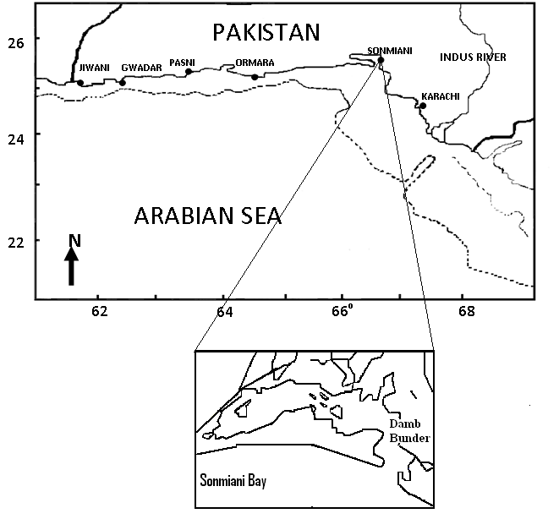

Fig. 1. Coastal areas of Pakistan showing the location of Sonmiani Bay (Miani Hor) Lagoon.

Sampling methodology
The shrimps were procured once in a month from the local mole holders (middle man) from ice fishery landings, during the period of July, 2006 to June, 2007.
In the laboratory, the procured shrimp samples were sorted, sexed and identified to species level according to Tirmizi and Bashir (1973) and Bianchi (1985). The specimens of P. indicus were dissected and colours of ovaries and size were noted to determine the stages of maturity for each penaeid shrimp. For histological studies, ovaries were fixed in Bouin’s solution for 48h. After fixation ovaries were passed through different grades (70% to 100%) of alcohol. This was followed by dehydration, clearing, embedding and the embedded gonads were sectioned at 6µm; then stained with Ehrlich Hematoxylin and eosin following Humason (1967).
To determine the spawning period, the percentage of females with ripe and spent stages were combined and are grouped as either just ready to spawn, spawning or just spawned. The months in which the highest percentage of spawning females was observed was considered to be the spawning period.

Statistical analysis
Monthly data were grouped into seasons, to observe the seasonal pattern and variability in ovarian maturation stages. One way analysis of variance (ANOVA) with nested treatment arrangement were carried out by using the statistical package Minitab (Version 11.12) for differences in ovarian developmental stages (colouration) and morphological character such as total length (TL), carapace length (CL), rostral length (RL) and telson length (Ts.L). Test of significance were accepted as significant at alpha = < 0.05.
The size at first maturity (SFM) is the size at which individual was first taken with mature ovary and is considered as the size at which shrimps reach maturity. SFM was determined by calculating the proportion of mature individuals (nearly ripe III, ripe IV and spent stage V) in each size class (Total length) following Thomas (1974). The relative frequency of adults (%) in each size class was plotted and fitted as a sigmoid curve following the result of the logarithmic equation

y = 1 ,
1+e^{r} ^{(TL-TL}₅₀⁾
From the fitted curve, whereTL₅₀ was the total length at which 50% of the individuals attain sexual maturity, and r was the slope of the curve. The adjusted equation was fitted by the least squares regression method (Vazzoler, 1996; Bertini et al., 2007; Saher and Qureshi, 2010).

RESULTS

Ovarian maturation
In P. indicus five ovarian maturation stages were recognized by the variations in colour, as well as development and arrangements of cells. These stages were designated as undeveloped, developing, nearly ripe, ripe, and spent as described here:

Undeveloped stage
On the basis of visual assessment ovaries in this stage were small, thin, translucent, flaccid, pigment-less, difficult to remove and as well as difficult to distinguish from the underlying tissues, and invisible through the exoskeleton. This type of ovary was found in only young immature shrimps. On histological examination, at this stage the most abundant cells in the ovary were oogonia, which were part of the germinating epithelium. They were not uniformly distributed inside the ovary, but were clustered in a well defined area of the ovarian wall along the gonad, known as the “zone of proliferation”. When oogonia pass through the developmental stages of primary oocytes and secondary oocytes, they move from the zone of proliferation toward the center of the ovarian lobe (Fig. 2A).

Developing stage
During visual examination in this stage, ovaries increase in size and were easily distinguished from the other tissue. The colour of ovary becomes opaque to yellowish likely due to scattered pigment containing cells over the surface. The developing ova are visually larger than the undeveloped ova. When studied histologically, it was found that ovarian tissue at this stage were organized into chambers with small numbers of oogonia and an abundant number of yolkless oocytes (Fig. 2B).

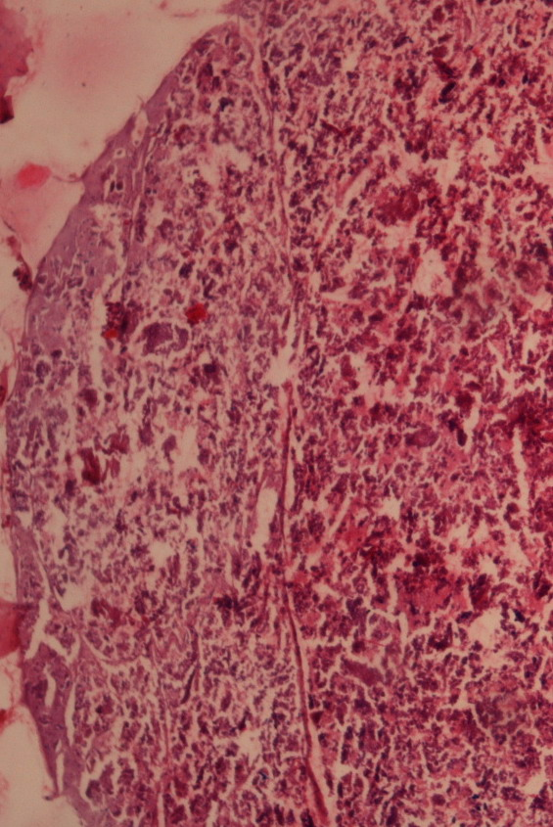  ZP  A | 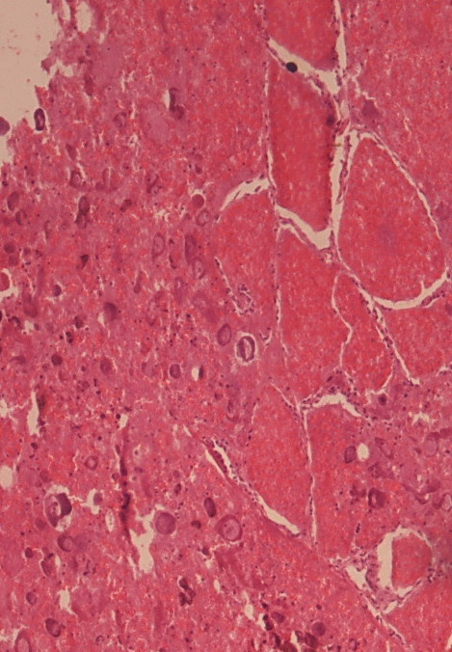  O  YO₁  B
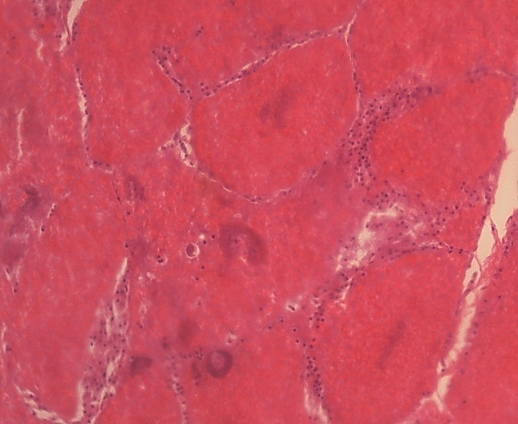  C | 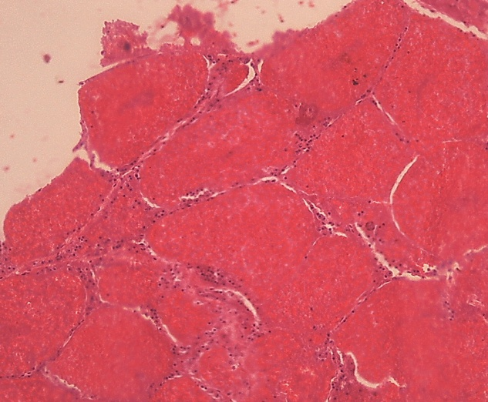  D
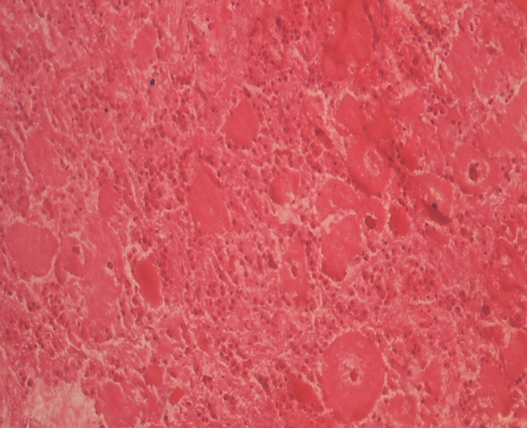  E | Fig. 2. Histological section of different stages of ovarian maturation of Penaeus indicus: A, undeveloped stage; B, developing stage; C, nearly ripe stage; D, ripe stage; E, spent stage. ZP, zone of proliferation; O, oogonia; YO₁, yolkless oocytes; YO₂, yolk-filled oocytes.

Nearly ripe stage
Visual examination showed that the ovary was light green in color and visible through the exoskeleton. The anterior and middle lobes of the ovary were fully developed and occupy the major part of the abdomen. Histological studies showed that the nearly ripe ovaries consisted of lower number of oogonia and yolkless oocytes but that yolk-filled oocytes were abundant. The yolk-filled oocytes were preferentially located in the outer region of the ovary (Fig. 2C).

Ripe stage
Visual study showed ripe ovaries was dark green in colour, clearly visible through the exoskeleton and fills virtually the whole space among the other organs. The ova were comparatively larger than in the preceding stages. This stage was believed to be the last stage of maturity before spawning as the largest ova were encountered only in this stage. Histological study shows ripe ovaries were characterized by the presence of fully mature oocytes. A typical distinctive feature of this stage was the cytoplasm of mature oocytes shows a conspicuous cortical rod at the cell periphery (Fig. 2D).

Spent stage
After spawning the ovary was designated as spent, at this stage colour of ovary was whitish to cream coloured. Microscopic examination according to the size and type of the cells was required to determine this stage accurately because it is difficult to differentiate between the spent ovary and undeveloped ovary through visual observations. Histological study of spent stage showed that the ovarian organization begins to disappear visually, leaving holes from the released oocytes, as well as remains of disintegrating mature oocytes (Fig. 2E).

Distribution of ovarian developmental stages
The monthly distribution of ovarian maturation stages was studied (Table I, Fig. 3). The ripe and nearly ripe ovaries were observed with peaks in March and in August. The developing ovaries were found in different months with peak in October. The spent ovaries were found from January to April with peak in February (Fig. 3). Seasonal distribution showed that the mature ovaries, ripe and spent (green or creamy), were observed during the post and pre monsoon seasons that could affect the reproductive behaviour of the shrimps (Table I, Fig.3).

Spawning season
The spawning of P. indicus during July 2006 to June 2007, in the Sonmiani Bay lagoon is shown in Table II. The major peak spawning activity was observed during the months of August to October and minor peak from February to March (Table II). Seasonal distribution showed that the peak spawning activities were observed during the post and pre monsoon seasons with the highest peak observed during post monsoon season (Table II,
Fig. 4).

Fig. 3. Monthly percent distribution of five ovarian developmental stages of Penaeus indicus from the Sonmiani Bay Lagoon, Balochistan during the study period July 2006 to June 2007.

0
10
20
30
40
50
60
Post
NE
Pre
SW
Season
Percent spawning of Penaeus indicus by seasons

Fig. 4. Seasonal distribution of percent spawning in Penaeus indicus from the Sonmiani Bay Lagoon, Balochistan, during the study period July 2006 to June 2007 (Post = post monsoon, NE = northeast monsoon, Pre = pre monsoon, SW = southwest monsoon).

Relationship between ovarian developmental stages, weight and size variations
Size variation of body weight, total length, carapace length, rostral length, and telson length were measured for all five stages (undeveloped, developing, nearly ripe, ripe and spent) in Penaeus indicus (Table III). When ovaries pass through developmental stages the body size and weight also

Table I.- Monthly and seasonal percent distribution of ovarian-developmental stages of Penaeus indicus at the Sonmiani Bay Lagoon, Balochistan during the study period July 2006 to June 2007.

Month | Season | Undeveloped (Translucent) N(%) | Developing (Yellow) N(%) | Nearly ripe (Light Green) N(%) | Ripe (Green) N(%) | Spent (Creamy/ White) N(%)
Jul. 06 | SW | 150(100) | 0.0 | 0.0 | 0.0 | 0.0
Aug. 06 | Post | 0.0 | 0.0 | 1(14.4) | 5(57.1) | 3(28.5)
Sep. 06 | Post | 178(100) | 0.0 | 0.0 | 0.0 | 0.0
Oct. 06 | Post | 2(8.3) | 2(8.4) | 0.0 | 0.0 | 16(83.3)
Nov. 06 | NE | 98(96.8) | 0.0 | 3(3.2) | 0.0 | 0.0
Dec. 06 | NE | 46(86.6) | 0.0 | 0.0 | 0.0 | 7(13.4)
Jan. 07 | NE | 82(96.2) | 3(3.8) | 0.0 | 0.0 | 0.0
Feb. 07 | Pre | 0.0 | 14(41.3) | 8(23.5) | 6(17.6) | 6(17.6)
Mar. 07 | Pre | 0.0 | 0.0 | 6(20) | 18(60) | 6(20)
Apr. 07 | Pre | 4(50) | 2(25) | 2(25) | 0.0 | 0.0
May 07 | SW | 62(75) | 0.0 | 0.0 | 0.0 | 21(25)
Jun. 07 | SW | 1(50) | 1(50) | 0.0 | 0.0 | 0.0

Table II.- Percent distribution of spawning and non spawning periods in Penaeus indicus, data collected from the Sonmiani Bay Lagoon, Balochistan during the study period July 2006 to June 2007.

Months | Season | Spawning N(%) | Non spawning  N(%)
Jul. 06 | SW | 0.0 | 150(100.0)
Aug. 06 | Post | 8(85.7) | 1(14.2)
Sep. 06 | Post | 0.0 | 178(100.0)
Oct. 06 | Post | 16(83.3) | 4(16.6)
Nov. 06 | NE | 0.0 | 101(100.0)
Dec. 06 | NE | 7(13.3) | 46(86.6)
Jan. 07 | NE | 0.0 | 85(100.0)
Feb. 07 | Pre | 12(35.2) | 22(64.7)
Mar. 07 | Pre | 24(80.0) | 6(20.0)
Apr. 07 | Pre | 0.0 | 8(100.0)
May. 07 | SW | 21(25.0) | 62(75.0)
Jun. 07 | SW | 0.0 | 2(100.0)

increases. The results of one way ANOVA showed significant difference between ovarian maturation and developmental stages (colouration) and morphological character such as: total length (F = 29.05, P< 0.0005), carapace length (F = 18.81, P < 0.0005), rostral length (F = 4.73, P < 0.0005) and telson length (F = 7.46, P < 0.0005).

Mean size at maturity
A total of 753 females specimens of P. indicus were studied during the study period , their size ranged from 3.1-25.0 cm. P. indicus were
Table III.- Summary statistics of morphometric measurements of ovarian-developmental stages of Penaeus indicus collected from Sonmiani Bay Lagoon, Balochistan during the study period July 2006 to June 2007 (SD, Standard Deviation; Min, Minimum; Max, Maximum).

Stages | Variable | No | Mean±SD | Min | Max
Undeveloped | Wt (g)  TL (cm)  CL (cm)  RL (cm)  Ts.L (cm) | 225  225  225  225  225 | 11.55±4.5  12.59±2.0  4.87±0.8  3.04±0.4  1.46±0.2 | 2.3  3.4  2.7  1.5  0.9 | 29.6  16.8  6.4  4.1  2.0
Developing | Wt (g)  TL (cm)  CL (cm)  RL (cm)  Ts.L (cm) | 135  135  135  135  135 | 13.60±5.6  12.95±2.4  4.96±0.9  3.15±0.4  1.49±0.3 | 3.7  10.5  3.5  2.3  1.0 | 82.8  22.6  8.6  4.9  2.9
Nearly ripe | Wt (g)  TL (cm)  CL (cm)  RL(cm)  Ts.L(cm) | 181  181  181  181  181 | 14.26±11.6  13.68±1.7  5.25±0.7  3.25±1.5  1.56±0.2 | 4.1  12.0  3.1  1.5  1.1 | 80.1  22.6  8.9  4.9  2.7
Ripe | Wt (g)  TL (cm)  CL (cm)  RL (cm)  Ts.L (cm) | 139  139  139  139  139 | 17.85±13.9  14.46±1.9  5.52±0.7  3.40±0.4  1.65±0.2 | 9.0  13.0  3.7  2.6  1.3 | 86.7  23.2  8.5  5.0  3.0
Spent | Wt (g)  TL (cm)  CL (cm)  RL (cm)  Ts.L (cm) | 73  73  73  73  73 | 18.99±13.9  14.82±2.1  5.67±4.2  3.43±2.5  1.70±0.2 | 9.1  12.9  5.2  3.2  1.4 | 81.4  23.9  9.2  5.0  2.9

grouped into 3 cm size classes and the percentage occurrence in each stage of maturity in these groups was calculated. P. indicus with ovaries with nearly ripe (III), ripe (IV) and spent (V) stages have been

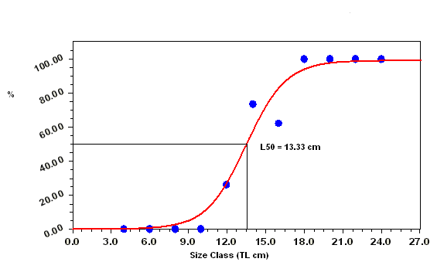

Fig. 5. Sigmoid model for Penaeus indicus size at sexual maturity showing L₅₀ for shrimp from the Sonmiani Bay Lagoon Balochistan, during the study period July 2006 to June 2007.

grouped under the mature shrimps while the undeveloped (I) and developing (II) stages were considered immature for the purpose of calculating the size at maturity. From Table IV it could be seen that all females were immature up to a total length of 9.1-11.0 cm. Mature individuals were found to have total length of 11.1 cm and above thus the size at first maturity appears to be about 11.1 cm total length. However, in the size group of 11.1-13.0 cm the percentage of immature individuals was more than mature ones. It was also observed that although some individuals were found to be mature at the size of 11.1-13.0 cm, the majority of sexually mature female shrimp were about 13.1 to 15.0 cm size. The size at which L₅₀ of the population was morphologically mature is shown in Figure 5. The estimated size at onset of sexual maturity was 13.33 cm.

DISCUSSION

In the present study, to determine the degree of ovarian development of females in P. indicus the macroscopic and microscopic characteristics of the gonad developmental stages were correlated. Results show five developmental stages on the basis of ovarian coloration and histological studies (undeveloped, developing, nearly ripe, ripe and spent). Other reports from Pakistan based on the colour and histological study of the ovaries of shrimps describe four to six maturation stages; there are: four stages in P. merguiensis and M. affinis (Van Zalinge et al., 1987), four in P. penicillatus, P. merguiensis and M. affinis (Ayub and Ahmed, 1992), five in penaeid shrimp (Sultana, 1985), six in the P. penicillatus, P. merguiensis, M. affinis and Pp. stylifera (Ayub and Ahmed, 2002). A survey of the literature shows that three to ten ovarian developmental stages of shrimps have been observed on the basis of colour and histology (Table V).
Castille and Lawrence (1991) reported that an immature gonad can not be distinguished through the exoskeleton, and even the diameter of gonadal lobule is smaller than that of the intestine. A spawned gonad is equally difficult to distinguish, due to its reduced size and whitish colouration. These indicators can cause confusion in the macroscopic identification of undeveloped and spawned ovary except for size variation. The direct observation of the gonad would reveal a filiform appearance in the case of spawned females similar to that of undeveloped female. Nevertheless, the color is not translucent but whitish, which would suggest that it, is a spent female rather than an undeveloped one. To establish the degree of maturation of a female with these characteristics, it is imperative to consider confirmation by microscopic observation (Quintero and Garcia, 1998). Another cause of confusion in determining sexual maturity in female shrimp may occur between the nearly ripe and ripe stages, because the gonad occupies the whole cephalothoracic cavity, and different shades of green can be observed. In our study, nearly ripe and ripe stages can easily be separately through histological examination, and a female is defined as being at the ripe stage when the gonads show an intense green color. Therefore, it is possible to conclude that ovarian stages described on the basis of the ovarian color and or morphology are not meaningless and they may be related to macroscopic variations within a similar histological feature.
Shrimps exhibit more than one spawning period in a year. The process of ovarian maturation goes through different reproductive stages undeveloped, developing, nearly ripe, ripe
and spent. After completion of the first spawning,

Table IV.- Percentage occurrence of females in different stages of maturity in the various size group data collected from the study area from July 2006 to June 2007.

Class Size | Tt N | I N(%) | II N(%) | III N(%) | IV N(%) | V N(%)
3.1-5.0 | 4 | 4(100) | - | - | - | -
5.1-7.0 |  | - | - | - | - | -
7.1-9.0 | 4 | 4(100) | - | - | - | -
9.1-11.0 | 40 | 31(77.5) | 9(22.5) | - | - | -
11.1-13.0 | 269 | 86(31.9) | 112(41.6) | 66(24.5) | 4(1.4) | 1(0.3)
13.1-15.0 | 349 | 75(21.4) | 17(4.8) | 95(27.2) | 114(32.6) | 48(13.7)
15.1-17.0 | 58 | 20(34.4) | 2(3.4) | 7(12.0) | 12(20.6) | 17(29.3)
17.1-19.0 | 3 | - | - | - | 2(66.6) | 1(33.3)
19.1-21.0 | 6 | - | - | 3(50) | 2(33.3) | 1(16.6)
21.1-23.0 | 18 | - | - | 7(38.8) | 8(44.4) | 3(16.6)
23.1-25.0 | 2 | - | - | - | 1(50) | 1(50)

shrimps rest in a developing stage before going through the maturation cycle again (Jayawardane et al., 2003). The spent stage is transitional since after spawning, the unspawned eggs are resorbed and redevelopment begins again from the developing stage. It appears that an undeveloped stage occurs only once in the life cycle of penaeid shrimps and after spawning, that maturation cycle starts from the developing stage (Crocos and Kerr, 1983; Tuma, 1967).
The spawning seasons was based on the proportion of ripe and spent stages of females. In general, spawning activity varied seasonally, with a bimodal pattern. In this study, the percentage of actively spawning P. indicus was the highest during the post monsoon season (Aug. to Oct.) and the secondary peak was observed in pre monsoon season (Feb. to Mar.). P. indicus spawns most of the year with peaks around March-April and July-August in the Sri Lanka (Jayawardane et al., 2002). Devi (1987) observed peaks in different months in different years from the coastal areas of India. Spatial and temporal differences in the spawning periods of P. indicus have been reported varying from October to May with two peaks in November to December and February to April in the Cochin backwaters (George, 1962), December-January and May-June in the coastal waters off Cochin (George et al., 1963), March-April in Madagascar waters (Crosnier, 1965), October-April in Cochin waters (Rao, 1968).
Previous studies from Pakistan reported variable spawning activity of penaeid shrimps. Hassan (1983) studied the spawning season of Penaeus species was spring and late summer, with Metapenaeus spawning in the winter, spring and late summer and Parapenaeopsis spawning in the summer. Zupanovic (1971) studied the spawning seasons of P. penicillatus as October to May and M. affinis as October to April. Van Zalinge et al. (1987) studied spawning activity of P. merguiensis throughout the year with peak spawning activity in April to May and August while M. affinis spawned from May to October. Ayub and Ahmed (1992) observed the two peaks of spawning major and minor peaks found in P. merguiensis from January to April and October, P. penicillatus from November to April and July and M. affinis from February to March and October, respectively. This is the first report for P. indicus from this area, and the behavior of this species appears to most closely resemble that of other penaeid species reported from this region.
Environmental factors which influence penaeid prawns are water temperature, rainfall, river discharge, atmospheric temperature, wind speed, salinity, wind direction and tidal amplitude (Staples, 1983; Stoner, 1988). The salinity, is the major factor to determine the prawn population, induces the emigration of adult prawns, and influences the post larval recruitment (Garcia and Le Reste, 1981). The northern Arabian Sea and are influenced by two monsoon seasons the summer or southwest monsoon beginning in June lasts till September and

Table V.- Studies related to ovarian maturation stages in genus Penaeus, in chronological order.

Species | No. of stages | Name of stages | Region | Author | Year
P. setiferus | Five | undeveloped, developing, yellow stage, ripe and spent | - | King | 1948
P. duorarum | Five | - | Tortugas grounds, Florida | Cummings | 1961
P. merguiensis | Five | quiescent, developing, early maturity, ripe and spent | Gulf of Carpentaria, Australia | Tuma | 1967
Penaeus indicus  Metapenaeus affinis  Parapenaeopsis stylifera | Five | immature, early maturing, late maturing, mature and spent-recovering | India | Rao | 1968
P. duorarum  P. aztecus  p. setiferus | Three | undeveloped, developing or yellow, ripe or nearly ripe | Gulf of Mexico | Brown and Patlan | 1974
P. semisulcatus | Five | - | Palk Bay and Gulf of Mannar | Thomas | 1974
P. latisulcatus | Five | undeveloped, developing, early maturity, ripe and spent | Western Australia | Penn | 1980
P. monodon | Six | - | - | Moth | 1981
P. merguiensis | Five | immature, developing, early ripe, ripe and spent | Gulf of Carpentaria, Australia | Crocos and Kerr | 1983
P. japonicas  P. kerathurus  P. semisulcatus  M. stebbingi  M. monoceros | Five | immature, early mature, mature, late mature and spent | Mediterranean coast of Egypt | Adbel Razek | 1985
Penaeid shrimps | Five | immature or undeveloped, early maturing, late maturing, ripe or mature and spent | Pakistan | Sultana | 1985
P. merguiensis  M. affinis | Four | immature, maturing, mature and spent | Pakistan | Van Zalinge et al. | 1987
P. japonicus | Ten | synapsis, chromatin nucleolus, early perinucleolus, late perinucleolus, oil globule I, oil globule II, yolkless, yolk granule, prematuration and maturation | Japan | Yano | 1988
P. monodon | Four | previtellogenic, vitellogenic, cortical rod stage and spent | Philippines | Tan-Fermin and Pudadera | 1989
P. semisulcatus | Six | immature, early maturing, maturing, late maturing, ripe and spent | Dammam waters of Kingdom of Saudi Arabia | El. Hady et al. | 1990
P. indicus | Five | immature, early maturing, late maturing, mature or ripe and spent | Bangladesh | Hossain et al. | 1991
P. indicus | Four | immature, maturing, mature and spent | - | Quinitio and Millamena | 1992
P. penicillatus  P. merguiensis  M. affinis | Four | undeveloped, developing, nearly ripe and fully ripe | Pakistan | Ayub and Ahmed | 1992
P. monodon | Six | primordial germ cells, chromatin nucleolus, perinucleolus, yolky, cortical rod stage and spent | Philippines | Quinitio et al. | 1993
P. kerathurus | Five | previtellogenic, early vitellogenic, late vitellogenic, mature and spent or degenerating | Gulf of Cadiz, Spain | Medina et al. | 1996
P. brasiliensis | Five | immature, developing, early ripe, ripe and spent | Mexican Caribbean Sea | Quintero and Garcia | 1998
P. penicillatus  P. merguiensis  M. affinis  Pp. stylifera | Six | undeveloped, developing, nearly ripe, fully ripe and resorbing and resorbing/developing | Pakistan | Ayub and Ahmed | 2002
Farfantepenaeus paulensis | Four | immature, developing, mature and spent | Southern Brazil | Peixoto at el. | 2003
P. indicus | Five | Undeveloped, developing, rnearly ripe, ripe and spent | Sonmiani, Pakistan | This study

winter or northeast monsoon that starts in November and ends in February. The bi-annual monsoonal cycle cause seasonal reversal of atmospheric and oceanic surface circulation pattern during these two monsoon seasons. The inter-monsoonal seasons have been known to be more productive than active monsoon seasons. Two peaks in spawning has been suggested in transitional periods (spring and fall) that separates cold and warm seasons (Garcia, 1985). High salinities in the creeks and coastal areas have been reported and may influence the spawning periods (Ahmed, 1999).
In the present study, the smallest size at first sexual maturity of P. indicus was found to be 11.1 cm total length, based on presence of mature ovaries however majority of individuals attained maturity at about 13.1 to 15.0 cm size class and the estimated size at onset of sexual maturity was 13.33 cm which agrees and in the same range as reported earlier for this specie. Jayawardane et al. (2002) reported that females of P. indicus attain sexual maturity at mean size 14.86 cm. Devi (1987) estimated the length at first maturity of P. indicus from the east coast of India, to be 12.5 cm. Subrahmanyam (1965) reported females of P. indicus attain maturity at the size of 14.0 cm.
The study of mean length, or age, at which shrimps spawn and recruitment occur are significantly important to fisheries, particularly the cycle of events leading to reproduction and the timing of gamete release (Niamaimandi et al., 2008). It has been observed that the size of target species and the size at maturity are reduced due to fishing pressure (Sparre and Venema, 1992). The size at sexual maturity is of special interest in fisheries management and is widely used as an indicator for minimum permissible capture size (Lucifora et al., 1999). Sindh Fisheries Ordinance, 1980 has declared a closed season for catching shrimps in June and July; it has also put a ban on the use of illegal nets with small mesh sizes (Gujjo, Katra and Bullo). The strict regulations and enforcement of these is essential for sustainable shrimp fisheries that may include reducing effort, setting bag limits, ban use of destructive gears, and illegal practices, reduce destruction of habitat through better legal frame work and implementation procedures and machinery. Closed seasons during peak recruitment period and spawning period would reduce juvenile mortality and provide chance for spawners to reproduce before falling prey to fishing mortality.
In conclusion, external characteristics of the ovary, such as color and size are closely related to the development and internal organization of the germ cells, and based on that data, size at maturity can be estimated. Therefore, it is possible to establish a practical scale or range of sizes to determine the maturation stage of female gonads in penaeid shrimps. This type of information is essential for the fisheries management, and will assist with the development of regulations of fishing efforts and catch size composition for the small-scale seine fishery in Pakistan, combined with habitat management and conservation.

ACKNOWLEDGEMENTS

This work was accomplished under the project “The Status of Shrimp’s Fisheries in Sonmiani Bay Lagoon” funded by Agricultural Linkage Program, Pakistan Agricultural Research Council (PARC) grant to NAQ and is gratefully acknowledged.

REFERENCES

ABDEL RAZEK, F.A., 1985. Contribution to the biology of penaeid prawns of the Mediterranean coast of Egypt. J. Egypt. Vet. med. Assoc., 45: 17-28.
ABDEL RAZEK, F.A., ABDEL RAHMAN, S.H. AND ZAGLOL, S.S., 1994. Aspects of the reproduction of the prawn Penaeus latisulcatus Kishinouya in the Gulf of Suez, Egypt. Mar. Sci., 7: 153-159.
AHMED, M., 1980. The breeding and recruitment of marine animals of the coast of Pakistan bordering the Arabian Sea. Proc. Pakistan Congr. Zool., 1: 55-96.
AHMED, M. 1999. Animal and plant communities of the present Indus Delta. In: The Indus River-Biodiversity, Resources, Humankind. Proceedings of a Symposium held at the Linnaean Society, Burlington house, London, 13-15 July, 1994. (eds. A. Meadows, and P. S. Meadows) Oxford University Press, Karachi pp. 12-30.
ARAGON-NORIEGA, E.A. AND GARCIA-JUAREZ, A.R., 2007. Comparison of two methods to determine the maturity period in penaeid shrimps (Decapoda, Penaeidae). Crustaceana, 80: 513-521.
AYUB, Z. AND AHMED, M., 1992. Maturation and spawning of some Penaeid shrimps of Pakistan (Arabian Sea). Mar. Res., 1: 29-35.
AYUB, Z. AND AHMED, M., 2002. A description of the ovarian development stages in penaeid shrimps from the coast of Pakistan. Aquat. Res., 33: 767-776.
BAUER, R.T. AND VEGA, L.W.R., 1992. Pattern of reproduction and recruitment in two sicyoniid shrimp species (Decapoda: Penaeoidea) from a tropical seagrass habitat. J. exp. Mar. Biol. Ecol., 161: 223-240.
BERTINI, G., BRAGA, A.A., FRANSOZO, A., DIAS, M.O., CORREA, A. AND FREIRE, F.A.M., 2007. Relative growth and sexual maturity of the stone crab Menippe nodifrons Stimpson, 1859 (Brachyura, Xanthoidea) in Southeastern Brazil. Brazilian Arch. Biol. Tech., 50: 259-267.
BIANCHI, G., 1985. FAO species identification sheets for fishery purpose. Field Guide — Commercial Marine and Brackish Water Species of Pakistan. FAO, Rome.
BROWN, A. JR. AND PATLAN, D., 1974. Color changes in the ovaries of penaeid shrimps as a determinant of their maturity. Mar. Fishw. Rev., 36: 23-26.
CASTILLE, F.L. AND LAWRENCE, A.L., 1989. Relationship between maturation and biochemical composition of the gonads and digestive glands of the shrimps Penaeus aztecus and Penaeus setiferus. J. Crustac. Biol., 9: 202-211.
CASTILLE, F.L. AND LAWRENCE, A.L., 1991. Reproductive studies concerning natural shrimp populations: a description of changes in the size and biochemical composition of the gonads and digestive glands in penaeid shrimp. In: Frontiers of shrimp research, volume 22 (eds. P.F. De Loach, W.J. Dougherty and M.A. Davidson), Elsevier Science Publishers. B. V. Amsterdam. The Netherlands, pp. 17-32.
COSTA, R.C. AND FRANSOZO, A., 2004. Reproductive biology of the shrimp Rimapenaeus constrictus (Decapoda: Penaeidae) in the Ubatuba region of Brazil. J. Crustac. Biol., 24: 274-281.
CROCOS, P.J. AND COMAN, G.J., 1997. Seasonal and age variability in the reproductive performance of Penaeus semisulcatus broodstock: optimizing broodstock selection. Aquaculture, 155: 55-67.
CROCOS, P.J. AND KERR, J.D., 1983. Maturation and spawning of the banana prawn Penaeus merguiensis in Albatross Bay, Gulf of Carpentaria, Australia. J. exp. Mar. Biol. Ecol., 69: 37-59.
CROCOS, P.J. AND VAN DER VELDE, T.D., 1995. Seasonal, spatial and interannual variability in the reproductive dynamics of the grooved tiger prawn Penaeus semisulcatus in Albatross Bay. Gulf of Carpentaria. Australia: the concept of active spawning. Mar. Biol., 122: 557-570.
CROCOS, P.J., 1987a. Reproductive dynamics of the grooved tiger prawn Penaeus semisulcatus in the northwestern Gulf of Carpentaria. Australia. Aust. J. Mar. Freshw. Res., 38: 79-90.
CROCOS, P.J., 1987b. Reproductive dynamics of the tiger prawn Penaeus esculentus and comparison with Penaeus semisulcatus in the northwestern Gulf of Carpentaria. Australia. Aust. J. Mar. Freshw. Res., 38: 91-102.
CROCOS, P.J., PARK, Y.C., DIE, D.J., WARBURTON, K. AND MANSON, F., 2001. Reproductive dynamics of endeavour prawns, Metapenaeus endeavouri and M. ensis, in Albatross Bay, Gulf of Carpentaria. Australia. Mar. Biol., 138: 63-75.
CROSNIER, A., 1965. Les crevettes penaeides du plateau continental Malgache, Cah. O.R.S.T.O.M. (Oceanography). 3: 158pp.
CUMMINGS, W.C., 1961. Maturation and spawning of the pink shrimp Penaeus duorarum Burkenroad. Trans. Am. Fishw. Soc., 90: 462-468.
DALL, W., HILL, B.J., ROTHLISBERG, P.C. AND STAPLES, D.J., 1990. The biology of the Penaeidae. In: Advances in marine biology (eds. J.H.S. Blaxter and A.J. Southward). Vol. 27, Academic press, London.
DEVI, S.L., 1987. Biology of Indian white shrimp Penaeus indicus H. M. Edwards from Kakinada, east coast of India. Indian J. Mar. Sci., 16: 246-248.
EL HADY, H.A., ABDEL RAZEK, F.A. AND EZZAT, A., 1990. Reproduction of Penaeus semisulcatus De HAAN in Dammam Water (Arabia Gulf), Kingdom of Saudi Arabia. Arch. Hydrobiol., 118: 241-251.
FISCHER, W. AND BIANCHI, G., 1984. FAO species identification sheets for fishery purposes. Western Indian Ocean (Fishing Area 51). Prepared and printed by FAO, United Nations. 1-6: pages variable.
GARCIA, S., 1985. Reproduction, stock assessment models and population parameters in exploited penaeid shrimp populations. In: Second Australian Natl. Prawn Seminar (eds. P.C. Rothlisberg, B.J. Hill and D.J. Staples), NPS2, Cleveland, Australia. pp. 139-158.
GARCIA S.AND LERESTE, L., 1981. Life cycles, dynamics, exploitation and management of coastal penaeid shrimp stocks. FAO Fish tech Pap 203:1-215.

GEORGE, M.J., 1962. Preliminary observations of the recruitment of postlarvae and growth of juveniles of the brown shrimp Penaeus aztecus, in Barataria Bay. Louisiana Wildlife and Fisheries Commission, 9th Biennial Report pp. 160–163.
GEORGE, M.J., RAMAN, K. AND NAIR, P.K., 1963. Observation on the off shore prawn fishery of Cochin. Indian J. Fish., 10: 460-499.
HASSAN, H., 1983. Distribution of penaeid larvae in the coastal waters of Pakistan. Ph.D. thesis, University of Karachi, Pakistan. Pp. 288.
HIDEO, S., 2001. Maturation and spawning of the small penaeid shrimp Metapenaeopsis dalei in Tosa Bay, Pacific coast of southern Japan. Fishw. Sci., 67: 444-448.
HOSSAIN, M.M., KARDER, M.A. AND INSLAM, K.S., 1991. Study on the internal sex organs in reared Indian white prawn Penaeus indicus, H. M. Edwards, 1837. Bangladesh J. Zool., 19: 77-83.
HUMASON, G.L., 1967. Animal tissue techniques. W. H. Freeman. San Francisco, pp. 569.
JAYAWARDANE, P.A.A.T., MCLUSKY, D.S. AND TYTLER, P., 2002. Reproductive biology of Penaeus indicus (H. Milne Edwards, 1837) from the western coastal waters of Sri Lanka. Asian Fish. Sci., 15: 315-328.
JAYAWARDANE, P.A.A.T., MCLUSKY, D.S. AND TYTLER, P., 2003. Reproductive biology of Metapenaeus dobsoni (Miers, 1878) from the western coastal waters of Sri Lanka. Asian Fish. Sci., 16: 91-106.
KING, J.E., 1948. A study of the reproductive organs of the common marine shrimps, Penaeus setiferus (Linnaeus). Biol. Bull., 94: 244-262.
LUCIFORA, L.O., VALERO, J.L. AND GARCIA, V.B., 1999. Length at maturity of the green-eye spurdog shark, Squalus mitsukuii (Elasmobranchii: Squalidae) from the SW Atlantic, with comparisons with other regions. Mar. freshw. Res., 50: 629-632.
MEDINA, A., VILA, Y., MOURENTE, G. AND RODRIGUEZ, A., 1996. A comparative study of the ovarian development in wild and pond-reared shrimp, Penaeus kerathurus (Forskal, 1775). Aquaculture, 148: 63-75.
MINAGAWA, M., YASUMOTO, S., ARIYOSHI, T., UMEMOTO, T. AND UEDA, T., 2000. Interannual, seasonal, local and body size variations in reproduction of the prawn Penaeus (Marsupenaeus) japonicus (Crustacea: Decapoda: Penaeidae) in the Ariake Sea and Tachibana Bay, Japan. Mar. Biol., 136: 223-231.
MOTH, H., 1981. Studies on the fisheries biology of the giant tiger prawn, Penaeus monodon in the Philippines. Technical Report No. 7. SEAFDEC Aquaculture Department Iloio, Philippiens. 128 pp.
NIAMAIMANDI, N., ARSHAD, A., DAUD, S.K., SAED, C.R. AND BAHRAM, K., 2008. Reproductive biology of the green tiger prawn (Penaeus semisulcatus) in coastal waters of Bushehr, Persian Gulf. ICES J. Mar. Sci., 1-7.
PEIXOTO, S., CAVALLI, R.O., INCAO, F.D., MILACH, A.M. AND WASIELESKY, W., 2003. Ovarian maturation of wild Farfantepenaeus paulensis in relation to histological and visual changes. Aquacul. Res., 34: 1255-1260.
PENN, J.W., 1980. Spawning and fecundity of the western king prawn, Penaeus latisulcatus, in western Australian waters. Aust. J. Mar. Freshw. Res., 31: 21-35.
PRIMAVERA, J.H., 1980. Sugpo (Penaeus monodon) broodstock. Aqua Guide Series No. 1. Aquaculture Department, SEAFDEC. Iloilo, Philippines.
QUINITIO, E.T. AND MILLEMENA, O.M., 1992. Ovarian changes and female specific protein levels during sexual maturation of white shrimps Penaeus indicus. Israel J. Aquacul. Bamidgeh., 44: 7-12.
QUINITIO, E.T., CABALLERO, R.M. AND GUSTILO, L., 1993. Ovarian development in relation to changes in the external genitalia in captive Penaeus monodon. Aquaculture, 114: 71-81.
QUINTERO, M.E. AND GARCIA, A., 1998. Stages of gonadal development in the spotted pink shrimp Penaeus braslliensis. J. Crust. Biol., 18: 680-685.
RAO, P.V., 1968. Maturation and spawning of the penaeid prawns of the southwest coast of India. FAO Fish. Rep., 57: 285-302.
RASOOL, F., TUNIO, S., HASNIAN, S.A. AND AHMAD, E., 2002. Mangrove conservation along the coast of Sonmiani, Balochistan, Pakistan. Trees, 16: 213-217.
SAHER, N. AND QURESHI, N.A., 2011. Relative growth and morphological sexual maturity of Ilyoplax frater (Brachyura: Ocypodoidea: Dotillidae) from mangrove area of Korangi creek. Pakistan. J. Zool. 43:
SAIFULLAH, S.M. AND RASOOL, F., 1995. A preliminary survey of mangroves of Balochistan. WWF—Pakistan Project Report Pp. 1-99.
SAIFULLAH, S.M., GUL, S. AND RASOOL, F., 2004. Anomalous aerial roots in grey mangroves of and arid climate lagoon. Pakistan J. Bot., 36: 463-466.

SPARRE, P. AND VENEMA, S.C., 1992. Introduction to tropical fish stock assessment. Part 1. Manual FAO Fish. Tech., Pap. 1: 376.
SUBRAHMANYAM, C.B., 1965. On the reproductive cycle of Penaeus indicus (M. Edw.). J. Mar. Biol. Assoc. India, 7: 284-290.
SULTANA, R., 1985. A comparative study of reproductive organ of selected penaeid prawns of Pakistan. M.Phil. thesis, University of Karachi.
TAN-FERMIN, J.D. AND PUDADERA, R.A., 1989. Ovarian maturations stages of the wild giant tiger prawn Penaeus monodon Fabricus. Aquaculture, 77: 229-242.
THOMAS, M.M., 1974. Reproduction, fecundity and sex ratio of the green tiger prawn Penaeus semisulcatus De Haan. Indian J. Fishw., 21: 152-163.
TIRMIZI, N.M. AND BASHIR, Q., 1973. Shore and off-shore penaeid prawns of northern Arabian Sea. University Karachi Department Publication, Pp. 77.
TUMA, D.J., 1967. A description of the development of primary and secondary sexual characters in the banana prawns. Penaeus merguiensis De Man (Crustacea: Decapoda: Penaeinae). Aust. J. Mar. Freshw. Res., 18: 73-88.
VAN ZALINGE, N.P., KHALILUDDIN, M. AND KHAN, W., 1987. Description of the shrimp fishery including a stratified sampling scheme for shrimps landings and effort at Karachi Fish Harbour. FAO, FI: DP/PAK/77/033 Field Document 7, pp. 56.
VAZZOLER, A.E.A.M., 1996. Biologia da reprodução de peixes teleósteo: teorias e prática. Maringá: EDUEM. 169p.
YANO, I., 1988. Oocyte development in the kuruma prawn Penaeus japonicus. Mar. Biol., 99: 547-553.
ZUPANOVIC, S., 1971. Shrimp explorations off the coast of West Pakistan. FAO Report, pp. 1-88.

(Received 8 April 2010, revised 5 July 2010)

